Submitted by:

K. NABI RASUL 22091A3726

S. VENU GOPAL 22091A3754

M. KALYAN 22091A3716

Under the Guidance of Mentor
Mr. T. MUNEIAH, M. Tech
Assistant Professor, Dept. of CSE (CS)



DEPARTMENT OF CSE (CYBER SECURITY)
RGM COLLEGE OF ENGINEERING & TECHNOLOGY

(AUTONOMOUS)
Approved by AICTE, New Delhi; Affiliated to JNTUA-Ananthapuramu, Accredited by NBA (6-Times); Accredited by NAAC with ‘A+’ Grade (Cycle-3), New Delhi;
World Bank Funded Institution; Recognized UGC-DDU Kaushal Kendra;
NANDYAL – 518501 (ESTD -1995)
Batch: 2022-26

Submitted by:

K. NABI RASUL 22091A3726

S. VENU GOPAL 22091A3754

M. KALYAN 22091A3716

Under the Guidance of Mentor

Mr. T. MUNEIAH M.Tech
Assistant Professor, Dept. of CSE (CS)

DEPARTMENT OF CSE (CYBER SECURITY)
RGM COLLEGE OF ENGINEERING & TECHNOLOGY

(AUTONOMOUS)
Approved by AICTE, New Delhi; Affiliated to JNTUA-Ananthapuramu, Accredited by NBA (6-Times); Accredited by NAAC with ‘A+’ Grade (Cycle-3), New Delhi;
World Bank Funded Institution; Recognized UGC-DDU Kaushal Kendra;
NANDYAL – 518501 (ESTD -1995)
Academic Year: 2025-26

Rajeev Gandhi Memorial College of Engineering & Technology

(AUTONOMOUS)
Approved by AICTE, New Delhi; Affiliated to JNTUA-Ananthapuramu, Accredited by NBA (6-Times); Accredited by NAAC with ‘A+’ Grade (Cycle-3), New Delhi;
World Bank Funded Institution; Nandyal (Dist.)– 518501.A.P


(ESTD – 1995)
DEPARTMENT OF CSE (CYBER SECURITY) CERTIFICATE
This is to certify that K. NABI RASUL (22091A3726), S. VENU GOPAL (22091A3754), and M. KALYAN (22091A3716) of IV - B.Tech II semester, have carried out the major project work entitled “ VOTING-BASED ENSEMBLE FRAMEWOEK FOR NETWORK OUTLIER DETECTION ” under the supervision and guidance of Mr. T. MUNEIAH, Assistant Professor CSE(Cyber Security) Department , in Partial fulfillment of the requirement for the award of Degree of Bachelor of Technology in CSE (Cyber Security) and Rajeev Gandhi Memorial College of Engineering & Technology (Autonomous), Nandyal is a bonafied record of the work done by them during 2025-2026.

Project Guide Head of the Department

Mr. T. Muneiah _{M.} _{Tech} Dr. R. Kaviarasan _{M.} _{Tech,} _{Ph.D}

Assistant Professor Assoc Professor Dept of CSE(CS)

Candidate’s Declaration

We hereby declare that the work done in this project entitled “VOTING-BASED ENSEMBLE FRAMEWORK FOR NETWORK OUTLIER
DETECTION” submitted towards completion of a major project in IV Year II Semester of B. Tech CSE (Cyber Security) at the Rajeev Gandhi Memorial College of Engineering & Technology, Nandyal. It is an authentic record of our original work done under the esteemed guidance of Mr. T. MUNEIAH, Assistant Professor, Department of CSE (Cyber Security), RGMCET, Nandyal.

We have not submitted the matter embodied in this report for the award of any other Degree in any other institutions for the academic year 2025-2026

By

K. NABI RASUL

S. VENU GOPAL

M. KALYAN

Dept of CSE(CS), RGMCET

ACKNOWLEDGEMENT

We manifest our heartier thankfulness Pertaining to your contentment over our project guide Mr. T. Muneiah, Assistant Professor of the CSE(Cyber Security) Department with whose adroit concomitance the excellence has been exemplified in bringing out this project to work with artistry.

We express our gratitude to Dr. R. Kaviarasan Garu, Head of the Department of CSE (Cyber Security) and all the Teaching staff members of the CSE (Cyber Security) department of Rajeev Gandhi Memorial College of Engineering & Technology (autonomous) for providing continuous encouragement and cooperation at various steps of our project successful.

Involuntarily, we are perspicuous to divulge our sincere gratefulness to our Principal, Dr. T. Jaya Chandra Prasad Garu, who has been observed posing valance in abundance towards our individuality to acknowledge our project work tangentially.

At the outset, we thank our honourable Chairman Dr. M. Santhi Ramudu Garu, for providing us with exceptional faculty and moral support throughout the course.

Finally, we extend our sincere thanks to all the non – teaching Staff Members of CSE(Cyber Security) Department who have co - operated and encouraged us in making our project successful.

Whatever ones does, Whatever one achieves, the first credit goes to the Parents be it not for their love and affection, nothing would have been responsible. We see in every good that happens to their love and blessings.

By
K. NABI RASUL 22091A3726
S. VENU GOPAL 22091A3754
M. KALYAN 22091A3716

ABSTRACT

In light of the increasing number of cyber-attack methods used against current network infrastructures, the development of a reliable anomaly-based detection system has become essential. This paper presents an efficient Network Outlier Detection System (NODS) that reliably detects and classifies malicious traffic on computer networks. The system uses the NSL-KDD and CICIDS2017 intrusion detection benchmark datasets. A thorough preprocessing stage, involving Min-Max and Z-Score normalizations, is conducted prior to implementing PCA and CFS for dimensionality reduction and feature optimization. Several machine learning classifiers such as SVM, Naïve Bayes, Decision Tree, Random Forest, and the Voting Classifier algorithm are developed for comparative analysis of their performances. The experimental results indicate that the Voting Classifier model performs the best in the comparison, delivering an accuracy of 98.6%, precision of 98.7%, recall of 98.7%, F1-score of 98.6%, and AUC of 0.989.
Keywords: Anomaly detection, Intrusion detection systems (IDS), Network security, Ensemble learning, Feature selection, Machine learning.

 | CONTENTS
Chapter No | Title | Page No
1. | INTRODUCTION
1.1 | Motivation | 1-2
1.2 | Objectives | 2
1.3 | Organization of Thesis | 2-3
2. | LITERATURE REVIEWS
2.1 | Introduction to Problem | 4
2.2 | Survey on Literature reviews | 4-7
2.3 | Comparison of all the existing methods. | 8-9
2.4 | Summary | 10
3. | PROPOSED SYSTEMS
3.1 | Introduction | 11
3.2 | Working Principle | 12
3.3 | Algorithm | 12-13
3.4 | Architecture diagram | 14-23
3.5 | Summary | 24
4. | SYSTEM REQUIREMENT SPECIFICATION
4.1 | Requirements Analysis | 25
4.2 | Software Requirements Specifications | 25
4.3 | Functional Requirements | 25
4.4 | Non- Functional Requirements | 25
4.5 | Software Requirements | 25-26
4.6 | Hardware Requirements | 27
5. | MODULES
5.1 | Data Set Collection | 28
5.2 | Exploratory Data Analysis | 29

  - Model Selection & Training 29
  - Model Evaluation and Visualization 30
- IMPLEMENTATION TOOLS 31-33

EXPERIMENTAL RESULTS
 | 7.1 | Simulation environment | 34
 | 7.2 | Simulation Settings | 34
 | 7.3 | Performance Metrics | 34-35
 | 7.4 | Graph with explanation | 35-36
 | 7.5 | Tabular results | 37-38
 | 7.6 | Screenshot of Implementation | 39-47
8. |  | CONCLUSION AND FUTURE DIRECTION | 48-50
 |  | REFERENCES | 51-52
ANNEXURE – I Turnitin Report
ANNEXURE – II Certificates of Publication ANNEXURE – III Published Papers

Abbreviation Full Form
NODS Network Outlier Detection System
IDS Intrusion Detection System
NOD Network Outlier Detection
SVM Support Vector Machine
GNB Gaussian Naïve Bayes
KNN K-Nearest Neighbour
DT Decision Tree
RF Random Forest
CNN Convolutional Neural Network
SCNN Shepard Convolutional Neural Network
PSO Particle Swarm Optimization
GAN Generative Adversarial Network
IWO Invasive Weed Optimization
XAI Explainable Artificial Intelligence
SHAP Shapley Additive Explanations
LIME Local Interpretable Model-agnostic Explanations
AUC Area Under Curve
ROC Receiver Operating Characteristic
AUC-ROC Area Under Receiver Operating Characteristic Curve FPR False Positive Rate
FNR False Negative Rate
NSL-KDD NSL Knowledge Discovery in Databases Dataset
CICIDS Canadian Institute for Cybersecurity Intrusion Detection System Dataset DoS Denial of Service
DDoS Distributed Denial of Service
R2L Remote to Local
U2R User to Root
WSN Wireless Sensor Network
IoT Internet of Things
SRS Software Requirements Specification
PCA Principal Component Analysis
CFS Correlation-based Feature Selection
CV Cross Validation
SQL Structured Query Language

Figure No. | Title | Page No.
Fig. 1. | System Architecture | 14
Fig. 2. | Data Flow | 15
Fig. 3. | Use Case | 17
Fig. 4. | Class | 18
Fig. 5. | Activity | 19
Fig. 6. | Sequence | 20
Fig. 7. | Collaboration | 21
Fig. 8. | Component | 22
Fig. 9. | Deployment | 23
Fig. 10. | NSL-KDD Dataset | 28
Fig. 11. | CICIDS Dataset | 28
Fig. 12. | NSL-KDD Dataset Results Graph | 35
Fig. 13. | CICIDS Dataset Results Graph | 36
Fig. 14. | Screenshots of Implementation | 39-47

Table No. Title Page No.

2.3 Comparison of all the Existing Methods 8-9

Software Requirements 26

Hardware Requirements 27

Tabular Results 37-38

Table 1: Performance Evaluation – NSL KDD Dataset

Table 2: Performance Evaluation – CICIDS Dataset

- INTRODUCTION

The evolution of the internet and digital services has led to enhanced exposure of the systems to the cyber world. With networks expanding into cloud services, organizational networks, as well as personal devices, the risk of any attack or unauthorized access continues to rise.
With the evolution of the technology and increase in cyber-attacks, there have been several advancements made to the attacks. Threats such as DoS attack, DDoS attack, phishing, ransomware attacks and malware attacks can happen in organizations and even individual devices.
These cyber-attacks are often developed to exploit and bypass the conventional security measures.
Firewalls and signature-based intrusion detection systems were the basic means of providing security in the past. However, they rely only on pattern recognition and thus cannot protect against unknown threats.
Anomaly-based detection systems are the solution against unknown threats and other security challenges. It detects any deviation in the data from the normal pattern.
Through analysing the anomalies, it is then possible to determine the threat of intrusion.
In this project, we implement machine learning algorithms for intrusion detection in a network. Multiple classification systems are combined using the concept of ensemble learning technique.

  - Motivation

The ever-growing sophistication and prevalence of cyber-attacks on organizational/personal digital resources require improved forms of network security measures.
Traditional signature-based Intrusion Detection Systems (IDS) have, by nature, low detection capability for new or "zero-day" or "polymorphic" attacks which do not conform to previously defined signatures for attacks.
Two good data sets like NSL-KDD and CICIDS, along with developments in machine learning and ensemble modelling techniques, provide a way forward for creating accurate and low false alarms IDSs.
This work is motivated by the potential to significantly improve detection accuracy and robustness using ensemble learning strategies specifically, a Voting Classifier that aggregates

predictions from multiple heterogeneous models to overcome the limitations of single classifiers like SVM and Naïve Bayes.

  - Objectives

The major goal of this research paper is to develop a highly effective intrusion detection system based on anomaly detection that can detect abnormal network behaviours.
The proposed system seeks to integrate several machine learning algorithms such as support vector machine, naïve bayes, decision tree, and random forest and employ a voting-based approach to ensure that all the algorithms provide correct results.
Furthermore, another goal is to classify the traffic on the network using various data sets that contain both normal and malicious types of activities.
The system will incorporate performance measurements using measures such as accuracy, precision, recall, and F1 score.
Finally, a basic web interface will be created for interacting with the model.

  - Organization of Thesis

Chapter 2:
Discusses about the literature review their advantages and disadvantages

Chapter 3:
Highlights discuss about the proposed method

Chapter 4:
Covers the System Requirement Specification, hardware and software requirements.

Chapter 5:
Explains the system modules, as how the dataset is collected and exploratory data analysis to training the model and evaluating.

Chapter 6:
Describes the implementation tools, frameworks, and development environment used.

Chapter 7:
Presents the experimental results, including performance metrics, comparative graphs, tabular results, and implementation screenshots.

Chapter 8:
Concludes the thesis of the project and suggests future research directions.

- LITERATURE REVIEWS

  - Introduction to Problem

Network security has emerged as a major issue owing to the fast growth of internet-based systems. Along with technological advancements, the hackers have also devised innovative means to attack the network. The existing IDS systems are based on the traditional attack pattern, making them less effective for dealing with novel attacks.
In order to overcome this problem, various methodologies have been adopted in recent times including machine learning, deep learning, and hybrid IDS. These methodologies concentrate more on detecting any abnormal pattern in the network traffic instead of solely depending upon the predefined attack pattern. This chapter discusses some popular methods that have been introduced recently.

  - Survey on Literature Review

- This is about the literature review for identifying network outlier detection problems, examining ten significant research contributions that address the anomaly type of intrusion detection with machine learning, deep learning, ensemble methods, and optimization-driven approaches. Each method is analysed with respect to its technique, dataset, result, and key limitations.

- 10 Methods from different survey papers:

Method 1: SVM-KNN-PSO Ensemble for Intrusion Detection
In this research work, a combination of Support Vector Machine, K-Nearest Neighbour, and Particle Swarm Optimization algorithms was proposed by Aburomman and Reaz. In this framework, PSO was applied for optimizing the parameters of classifiers.
The outcomes indicated higher accuracy than individual models. The problem with this method is the computational overhead created by PSO algorithm that does not allow its application in real-time.

Method 2: KNN-Based IDS for Wireless Sensor Networks
Li et al. (2014) proposed an Intrusion Detection System based on the K-Nearest Neighbour method, which was created for wireless sensor networks (WSN). The KNN method was modified to be suitable for limited sensor node capacities, and the system performance was tested using WSN-related data. Although the accuracy of KNN for sensor network traffic is adequate, its algorithmic complexity depends on the number of examples used in the training set, which limits scalability on large datasets and leads to false positives in case of imbalance classes.

Method 3: NSL-KDD Benchmark Evaluation with Classical Classifiers
Dhanabal and Shantharajah (2015) conducted a comprehensive study evaluating classical classifiers — Decision Tree (J48), Naive Bayes, and SVM — on the NSL-KDD dataset. Their work systematically analysed the impact of feature selection on detection accuracy and demonstrated that NSL-KDD provides a more reliable evaluation environment than KDD Cup 99 by removing redundant records. Despite offering valuable baseline comparisons, the study did not incorporate ensemble methods or advanced feature optimization, resulting in moderate accuracy levels and higher false alarm rates compared to ensemble approaches.

Method 4: Deep Learning-Based IDS for IoT
Elnakib et al. (2023) suggested the Efficient Intrusion Detection Model (EIDM) by employing deep learning techniques in IoT intrusion detection systems. This model exploited CNN layers for the extraction of hierarchical spatial information from the network traffic data. EIDM demonstrated impressive detection accuracy when evaluated on IoT-based datasets with pre-existing attacks. Nevertheless, deep learning algorithms demand a considerable amount of labelled data for training purposes and are computationally intensive, thus rendering them unsuitable for deployment on IoT edge devices and highly vulnerable to overfitting on skewed datasets.

Method 5: GAN-Based Approach for Imbalanced Network IDS
In their paper published in 2023, Rao & Babu proposed a novel GAN-based solution intended for tackling class imbalance in network intrusion detection. This was achieved through a process wherein the GAN generator generated artificial attack instances corresponding to the minority class, which were then added to the dataset to train the classification model. Upon testing on datasets characterized by class imbalance problems in intrusion detection, this solution demonstrated an enhanced recall rate for attacks belonging to the U2R and R2L categories. The key limitation of this approach, however, is the unstable nature of GANs during training.

Method 6: XAI-Enabled IDS for Cyber-Physical Systems
Almuqren et al. (2023) proposed an explainable artificial intelligence (XAI)-enabled intrusion detection technique for secure cyber-physical systems, published in Applied Sciences. The method integrated SHAP (SHapley Additive exPlanations) values with ensemble classifiers to provide feature-level transparency in anomaly detection decisions. While this approach significantly enhanced model interpretability and trust among network administrators, the additional XAI computation layer increases inference latency, making it less suitable for real-time high-throughput network monitoring scenarios where sub-millisecond classification is required.

Method 7: Dragonfly-IWO-Shepard CNN for Cloud IDS
Sathiyadhas and Soosai Antony (2022) proposed a hybrid network intrusion detection system for cloud computing environments combining Dragonfly optimization, Invasive Weed Optimization (IWO), and a Shepard Convolutional Neural Network (SCNN). The Dragonfly-IWO algorithm performed optimized feature selection, while the SCNN performed classification. Evaluated on cloud-specific network traffic, the system achieved improved detection accuracy in cloud environments. The major drawback is the extreme algorithmic complexity and computational cost of combining three optimization/learning components, making it impractical for real-world deployment without high-performance cloud infrastructure.

Method 8: XAI-Based Anomaly Detection with Classification Methods
Wawrowski et al. (2021) examined the problem of anomaly and attack detection in network traffic by applying the concept of classical machine learning classification algorithms combined with explainability using XAI techniques in their work published in Procedia Computer Science. In their experiments, they used three types of models: Random Forest, Gradient Boosting, and Logistic Regression, which were enhanced using LIME (Local Interpretable Model-Agnostic Explanations). This technique increased the interpretability of these models but showed high variability in the detection process.

Method 9: Anomaly-Based Network IDS with Unsupervised Outlier Detection
An intrusion detection framework based on anomalies was proposed by Zhang & Zulkernine (2006), which incorporated both unsupervised and supervised learning methodologies in detecting attacks in networks. While the former utilized statistical clustering for identifying the nature of normal traffic, the latter involved classification through the use of labelled examples. The strength of this method lies in its ability to detect novel attacks without needing all labelled data to be provided. Nevertheless, the unsupervised method is highly dependent on its parameter settings, which can generate many false alarms.

Method 10: Comprehensive Survey of Internet Measurement for Cyber Security
Safaei Pour et al. (2023) presented a comprehensive survey of recent Internet measurement techniques for cyber security, published in Computers & Security. The survey analysed passive and active measurement techniques, traffic fingerprinting, anomaly detection pipelines, and their applications across enterprise, cloud, and IoT environments. The survey identified that most existing IDS frameworks lack integrated preprocessing pipelines combining normalization, the core gap addressed by the proposed framework in this thesis. The survey also noted that single-dataset evaluation limits the generalization assessment of proposed methods.

  - Comparison of all the Existing Method

Author / Title | Year | Method | Drawbacks
Aburomman & Reaz – SVM-kNN-PSO  Ensemble IDS | 2016 | SVM + KNN + PSO  Optimization | High computational overhead from PSO; not suitable for real-time large-scale detection
Li et al. – KNN-Based IDS for WSN | 2014 | K-Nearest Neighbour (KNN) | Poor scalability with high-volume traffic; high FPR under class imbalance
Dhanabal & Shantharajah – NSL-KDD Classical Classifier Study | 2015 | Decision Tree, Naive Bayes, SVM | No ensemble methods; moderate accuracy; higher false alarm rates
Elnakib et al. – EIDM Deep Learning for IoT | 2023 | Convolutional Neural Network (CNN) | Requires large labelled data & GPU; overfitting risk on imbalanced datasets
Rao & Babu – GAN-Based IDS for Imbalanced Data | 2023 | Generative Adversarial Network (GAN) | GAN training instability (mode collapse); unreliable synthetic sample diversity

Author / Title | Year | Method | Drawbacks
Almuqren et al. – XAI-Enabled IDS for Cyber-Physical Systems | 2023 | Ensemble & SHAP (XAI) | Increased inference latency; not suitable for real-time high-throughput monitoring
Sathiyadhas & Soosai Antony – Dragonfly-IWO-SCNN for Cloud | 2022 | Dragonfly-IWO & Shepard CNN | Extreme algorithmic complexity; impractical without high-performance cloud infrastructure
Wawrowski et al. – XAI + Classification for Anomaly Detection | 2021 | Random Forest, Gradient Boosting & LIME | Higher variance without ensemble aggregation; weak on minority-class attacks
Zhang & Zulkernine – Unsupervised Outlier IDS | 2006 | Unsupervised Outlier & Supervised Hybrid | Sensitive to parameter tuning; high FPR when traffic boundary shifts dynamically
Safaei Pour et al. – Internet Measurement Survey for Cyber Security | 2023 | Survey: Traffic Fingerprinting & Anomaly Detection | Lacks integrated preprocessing + ensemble pipeline; single-dataset evaluation limits generalization

  - Summary
The methods present in the literature are effective in network outlier and intrusion detection, but they’re having drawbacks like less accuracy, increased false positives, high computational overhead, and limited cross-dataset generalization. Most existing approaches also lack an integrated preprocessing pipeline that combines normalization, dimensionality reduction, and correlation-based feature selection within a unified detection framework. To overcome this drawback a new method is proposed which is discussed in chapter 3.

- PROPOSED SYSTEMS

  - Introduction
This The proposed system focuses on detecting abnormal network activity using a machine learning-based approach. Instead of depending on a single model, the system combines multiple classifiers to improve detection performance and reliability.
The system is designed to work with datasets such as NSL-KDD and CICIDS2017, which contain both normal and attack traffic records. These datasets are first processed to make them suitable for analysis. During preprocessing, unnecessary attributes are removed, missing values are handled, and the data is converted into a consistent format.
After preprocessing, label encoding is applied, where categorical values are translated into numerical form so that machine learning algorithms can perform operations on them. Feature selection follows, during which unnecessary input features are discarded. Only those which are considered to be the most valuable remain, allowing for improving the accuracy of the algorithm and saving computation time.
Then, the prepared dataset is split into two parts – training and testing. The former is fed to multiple models, namely Support Vector Machine (SVM), Naïve Bayes, Decision Tree, and Random Forest. They learn patterns and make independent predictions based on the provided information.
To increase the efficiency of the algorithm, the voting-based ensemble approach is utilized. It means that in the end, predictions made by all models are summed up, and final results are selected through voting. It allows overcoming the limitations of any specific model and achieving better results.
To evaluate the efficiency of the system, common metrics such as accuracy, precision, recall, and F1-score are employed. The latter allows measuring how well the system manages to distinguish between normal and abnormal network behaviour.
Ultimately, the system may be employed to predict whether some activity within the network is malicious or not.

  - Working Principle

The working principle of the proposed NODS follows a structured seven-stage pipeline:

Data Ingestion:
Network traffic data from NSL-KDD and CICIDS2017 datasets is loaded into the system for analysis.

Preprocessing:
Raw network features undergo label encoding (converting categorical attributes to numerical representations), Min-Max normalization (scaling features to [0,1]), and Z-score standardization.

Feature Selection:
PCA reduces the feature space by transforming original features into orthogonal principal components capturing maximum variance. CFS removes features with high inter-correlation and low correlation with the target class label.

Model Training:
SVM, Naive Bayes, Decision Tree, Random Forest, and Voting Classifier are trained on the pre-processed feature set using 80:20 train-test split with 5-fold cross-validation.

Ensemble Voting:
The Voting Classifier aggregates predictions from Bagging Classifier (Random Forest), Ada Boost Classifier, and Decision Tree Classifier using weighted majority voting.

Evaluation:
System performance is measured using accuracy, precision, recall, F1-score, AUC-ROC, FPR, and FNR metrics.

Prediction Interface:
A Flask-based web front-end allows authenticated users to input network traffic features and receive real-time predictions.

  - Algorithms

Support Vector Machine (SVM)
The optimization problem for SVM is as follows: minimize (1/2)||w||^2, where yi(w.xi
+ b) >= 1. This is achieved using an RBF kernel K (xi, xj) = exp (-gamma||xi - xj||^2), which helps classify instances in higher dimensional space where a linear classifier cannot be used. SVM is useful for high-dimensional network traffic data.

Gaussian Naive Bayes (GNB)
Naive Bayes applies Bayes theorem with conditional independence: P(C|X) proportional to P(C) multiplied by the product of P(xi|C). The Gaussian variant models each feature as a normal distribution. It is computationally efficient and suitable for real-time probabilistic classification of network traffic.

Decision Tree
The Decision Tree constructs a tree model where internal nodes represent feature tests, branches represent decision rules, and leaf nodes represent class labels. Information gain and Gini impurity are used as splitting criteria. It provides interpretable, transparent decision rules visible to network administrators.

Random Forest
Random Forest constructs multiple decision trees using bootstrap aggregation (bagging) and random feature subsets, then aggregates predictions via majority voting. This ensemble method reduces overfitting and improves generalization, while also providing feature importance scores useful for identifying key detection attributes.

Voting Classifier (Ensemble Extension)
The Voting Classifier combines Bagging Classifier (Random Forest), Ada Boost Classifier, and Decision Tree Classifier using weighted soft voting:
Final Prediction = argmax_c [Sum_i (w_i * I(h_i(x) = c))]
where w_i is the weight of classifier i determined by validation accuracy, and I(.) is the indicator function. Bagging Classifier reduces variance through bootstrap aggregation; Ada Boost Classifier focuses on misclassified instances to improve weak learners; and Decision Tree Classifier provides a strong baseline model. This approach achieves higher stability, improved generalization, and better resilience against overfitting.

  - Architecture Diagram

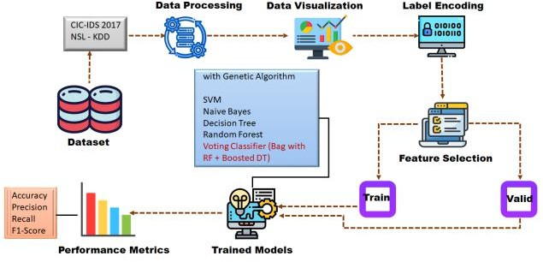

Fig.1. System Architecture Diagram

The architecture of the system illustrates the flow of data from input to output through the Network Outlier Detection System. Initially, the datasets including NSL-KDD and CICIDS2017 consisting of normal and attack data are fed into the system.
Data processing is performed in order to clean and preprocess the data. Visualization is also done to determine the trends and distribution within the dataset. Further, label encoding is performed on the categorical variables so that they could be understood by the algorithm. Feature selection technique is performed in order to retain only those features that are essential to reduce computation and increase efficiency. Splitting is done between the training and validation sets. Training phase involves application of various classification models such as SVM, Naïve Bayes, Decision Tree, and Random Forest. All these models are ensembled together in a voting classifier in order to achieve better performance.
Accuracy of the model is then measured with respect to various performance metrics, such as accuracy, precision, recall, F1 score, and the output is determined for the given data.

- Data Flow:

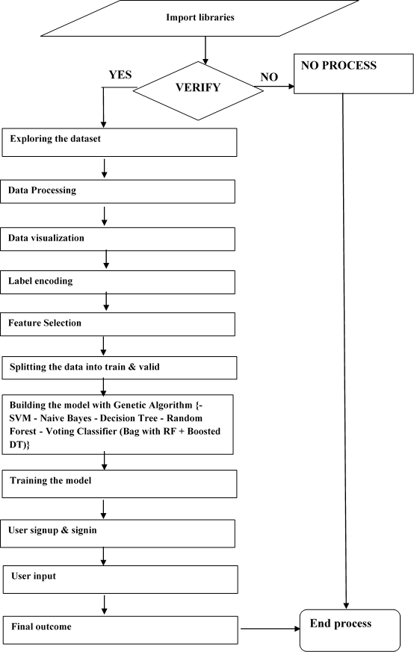

Fig. 2 Data Flow Diagram

The Data Flow Diagram (DFD) explains how data moves through the proposed Network Outlier Detection System. Instead of just showing blocks, it helps in understanding how raw network data gets transformed into meaningful predictions.
At the beginning, the system loads all the required libraries needed for data processing and machine learning. Before moving forward, it checks whether everything is properly initialized. If something fails at this stage, the process stops; otherwise, it continues.
Next, the dataset is explored to understand what kind of data we are dealing with. This includes checking the number of features, types of values, and how the data is distributed. After that, preprocessing is carried out. This step is important because raw data is usually messy and not directly usable. So, cleaning, normalization, and formatting are applied.
Once the data is prepared, visualization techniques are used to identify patterns and relationships. This helps in understanding which features might be useful for detecting attacks. Then comes label encoding, where categorical values are converted into numerical form so that machine learning models can process them. Feature selection is applied next to reduce unnecessary data and focus only on the most important features.
The dataset is then divided into training and testing parts. Different machine learning models are trained, and their outputs are combined using a voting-based approach.
Finally, the system takes user input and produces a prediction indicating whether the network activity is normal or suspicious.

- Use Case:

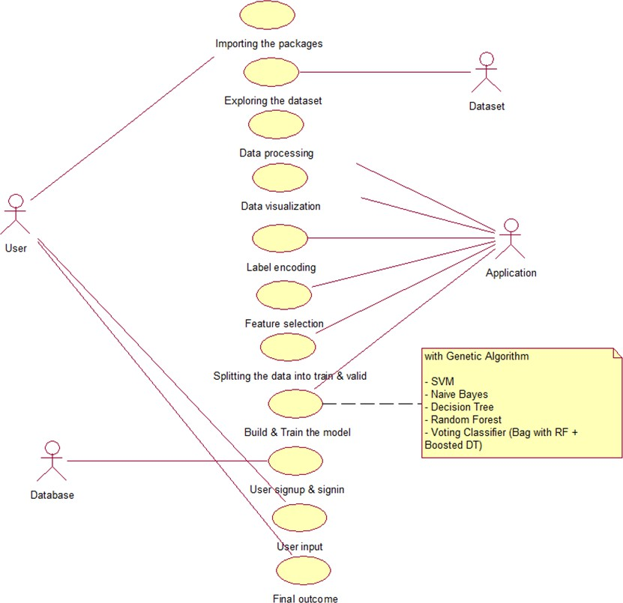

Fig. 3 Use Case Diagram

The Use Case Diagram shows how different users interact with the system and what actions they can perform.
In this system, the main user interacts with the application through a web interface. The user can perform several actions such as loading datasets, running preprocessing steps, training models, and getting predictions.
The dataset acts as an external source that provides network traffic data. The application processes this data step by step, including visualization, encoding, and feature selection. Another important part of the system is user authentication. The user must sign up and log in before accessing the prediction features. This ensures that only authorized users can use the system.
Overall, this diagram makes it clear that the system is designed to guide the user from data input to final prediction in a structured way.

- Class:
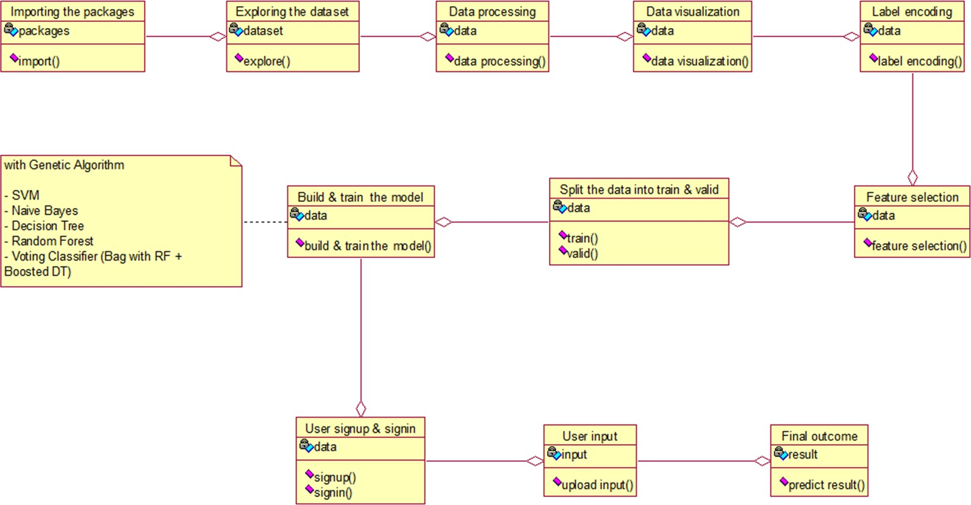

Fig. 4 Class Diagram

The Class Diagram represents the internal structure of the system by showing different classes and how they are connected.
Each class in the system has a specific responsibility. For example, one class handles loading and managing the dataset, while another is responsible for preprocessing tasks such as cleaning and normalization.
There is also a class dedicated to feature selection, which reduces the number of features and improves model performance. The model training class builds and trains different machine learning algorithms.
Another important class handles user interaction, including login and input submission. Finally, the output class is responsible for generating prediction results.

- Activity:
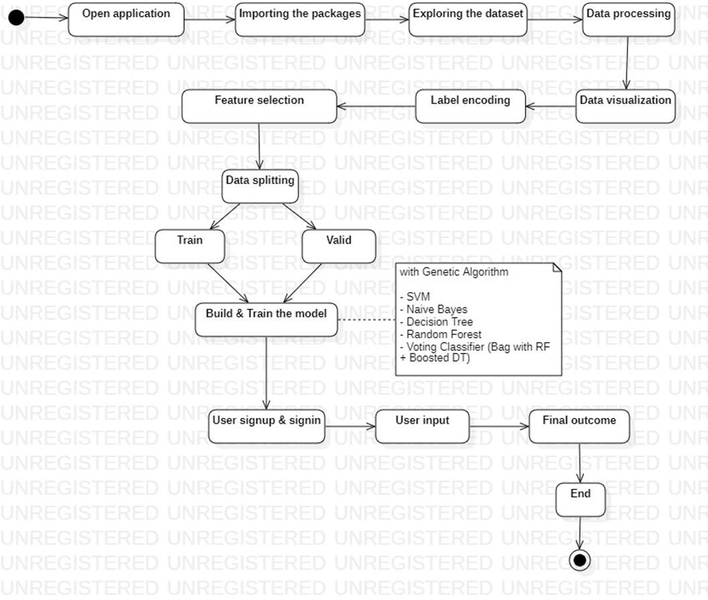

Fig. 5 Activity Diagram

The Activity Diagram describes the step-by-step workflow of the system.
The process starts when the user opens the application. The system then loads all necessary libraries and proceeds to load the dataset.
After loading the data, preprocessing is performed to clean and prepare it. Visualization is used to understand patterns, followed by encoding and feature selection. The dataset is then split into training and testing parts. The models are trained using this data, and an ensemble method is applied to combine their predictions.
Once training is completed, the user logs into the system and provides input data. The system processes this input and generates the final result.
This activity diagram clearly shows how the system flows from start to finish without skipping any important step.

- Sequence:

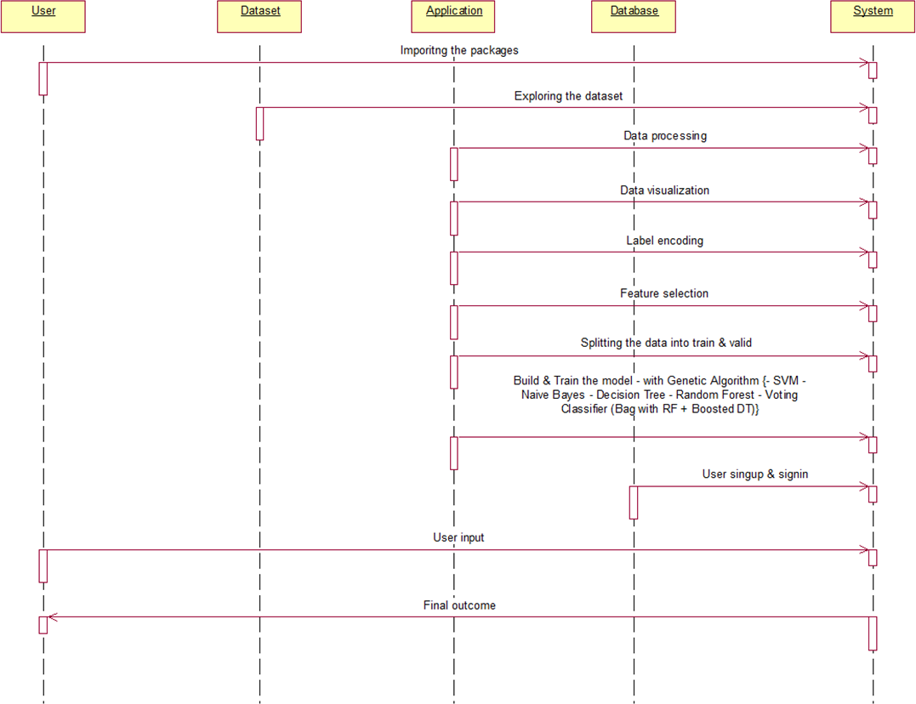

Fig. 6 Sequence Diagram

The Sequence Diagram explains how different parts of the system interact with each other over time. The process begins when the user starts the application. The system loads the dataset and performs all necessary preprocessing steps.
The application then communicates with the database to handle user authentication. Once the user logs in, they can provide input data. The system processes this input using trained models and returns the prediction result back to the user.
This sequence shows the order in which operations occur and how different components communicate during execution.

- Collaboration:

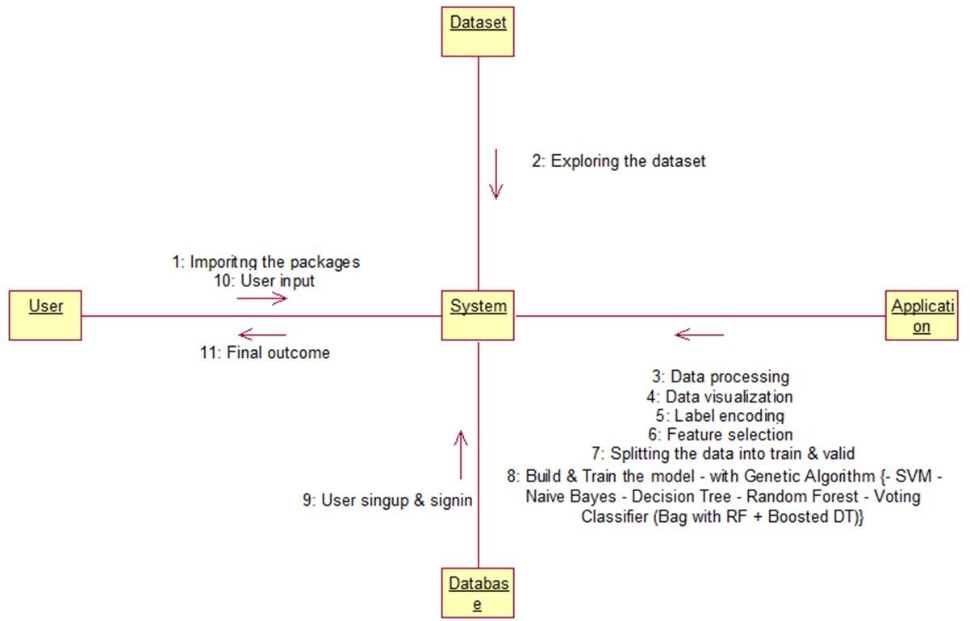

Fig. 7 Collaboration Diagram

The Collaboration Diagram focuses on how different components of the system work together.
The user interacts with the system by providing input and receiving output. The dataset supplies the necessary data for training and testing. The application acts as the core component that processes data, trains models, and generates predictions. The database supports the system by storing user information. All these components are connected and depend on each other to perform their tasks efficiently.
The diagram highlights the teamwork between different parts of the system.

- Component:

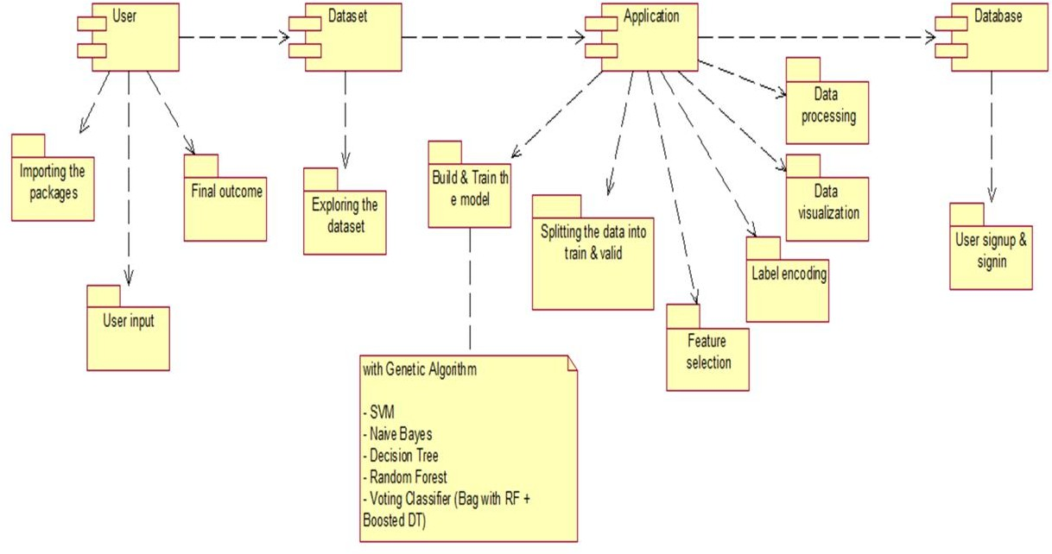

Fig. 8 Component Diagram

The Component Diagram shows the major parts of the system and how they are organized. The system is divided into different components such as the user interface, dataset module, processing module, and database.
The user interface allows users to interact with the system. The dataset module handles loading and managing data. The processing module performs preprocessing, feature selection, and model training.
The database stores user credentials and other necessary information. These components work together to ensure smooth functioning of the system.
This modular structure makes the system easier to maintain and scale.

- Deployment:
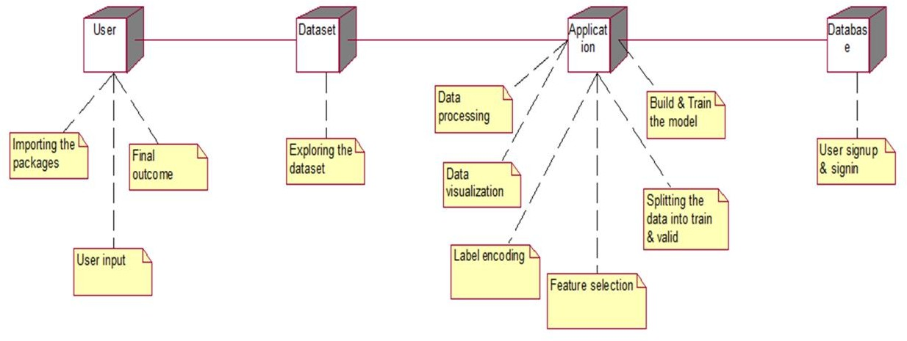

Fig. 9 Deployment Diagram

The Deployment Diagram shows how the system is set up in a real-world environment. The user accesses the system through a web browser on their device. The application runs on a server that handles all processing tasks.
The dataset is stored either locally or on a server, and the database manages user information. Communication between these components happens through network requests. This diagram gives a clear idea of how the system is deployed and how different parts interact in a real setup.

  - Summary
This chapter presented the proposed Voting-Based Ensemble Framework for Network Outlier Detection, detailing its working principle, the five classification algorithms employed, and the system architecture. The proposed framework overcomes the drawbacks of existing methods like poor generalization, high false positive rates, and lack of systematic feature optimization through a unified preprocessing pipeline and weighted ensemble voting evaluated on two benchmark datasets. Chapter 4 specifies the detailed system requirements for implementing this framework.

- SYSTEMS REQUIREMENTS

  - Requirement Analysis

This analysis for the proposed NODS identifies the key capabilities the system must support: real-time network traffic classification, multi-dataset training and evaluation, user-accessible web interface with authentication, scalable feature processing pipeline, and comprehensive performance evaluation.

  - Software Requirements Specifications (SRS)

The SRS defines the scope, constraints, and expected behaviour of the system. The NODS must process labelled network traffic datasets, apply preprocessing transformations, train and evaluate multiple classification models, generate performance reports, and provide a user interface for real-time prediction.

  - Functional Requirements
- The system shall accept network traffic datasets in CSV format (NSL-KDD and CICIDS).
- The system shall preprocess data including label encoding, Min-Max normalization, and Z-score standardization.
- The system shall apply PCA and CFS dimensionality reduction techniques.
- The system shall train SVM, Naive Bayes, Decision Tree, Random Forest, and Voting Classifier models.
- The system shall compute accuracy, precision, recall, F1-score, AUC-ROC, FPR, and FNR metrics.

  - Non- Functional Requirements
- Performance: The system shall complete model training within a reasonable time on standard hardware (i5 processor, 8GB RAM).
- Accuracy: The ensemble classifier shall achieve a minimum accuracy of 95% on both NSL-KDD and CICIDS2017 datasets.

- Reliability: The system shall correctly process all valid input data without runtime errors under normal operating conditions.
- Security: The web interface shall enforce user authentication, preventing unauthorized access to prediction functionality.
- Maintainability: The Python codebase shall be modular with separate scripts for preprocessing, training, evaluation, and the web interface.

  - Software Requirements

Component | Specification
Application Platform | Anaconda (Python distribution)
Primary Language | Python 3.8+
Frontend Framework | Flask 2.x
Backend / Notebooks | Jupyter Notebook
Database | SQLite
Front End Technologies | HTML5, CSS3, Java Script, Bootstrap 4
ML Libraries | Scikit-learn, NumPy, Pandas, Matplotlib, Seaborn
Operating System | Windows 10/11

  - Hardware Requirements

Component Name | Specifications
Operating System | Windows 10 or 11 (x64-bit)
Processor Level | Intel Core i5 or above
RAM | 8 GB or above
Storage | 25 GB available disk space or above
Display | 1280 x 720 minimum resolution

- MODULES
  - Data Set Collection NSL-KDD Dataset
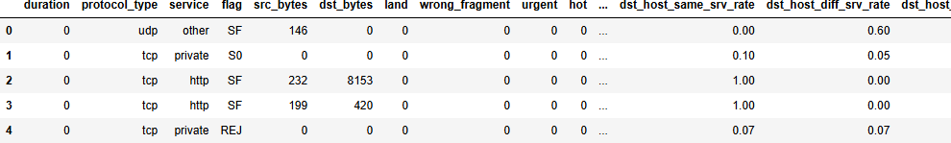

The NSL-KDD dataset (https://www.kaggle.com/datasets/hassan06/nslkdd) is a refined version of KDD Cup 99 containing labelled network connection records with 41 features. Traffic is categorized into NORMAL, DOS, PROBE, R2L, and U2R classes. NSL-KDD removes redundant records and provides balanced class distributions for reliable IDS evaluation.

CICIDS Dataset

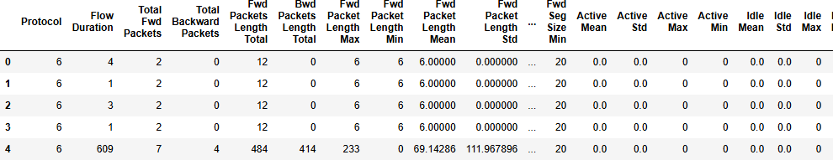

The CICIDS dataset (https://www.kaggle.com/datasets/dhoogla/cicids) contains modern network attack traffic including BENIGN, BOTNET, BRUTEFORCE, DDoS, DoS, INFILTRATION, PORTSCAN, and WEBATTACK categories. It represents realistic bidirectional traffic flows from contemporary attack scenarios.

  - Exploratory Data Analysis
- Data Loading: Importing datasets into Pandas Data Frames for analysis.
- Missing Value Analysis: Verifying and handling null values — no missing values were observed in either dataset.
- Class Distribution Analysis: Visualizing attack category distributions to understand class imbalance.
- Feature Distribution Visualization: Generating histograms and distribution plots for key features such as duration, packet size, and flow bytes.
- Correlation Analysis: Computing correlation matrix and heatmap to identify highly correlated feature pairs for CFS removal.
- Label Encoding: Converting categorical string labels (protocol type, service, flag) into numerical integer representations.
- Data Normalization: Applying Min-Max scaling to constrain all feature values to [0,1].

Model Selection & Training

Data Splitting
The pre-processed dataset is partitioned using an 80:20 train-test split with stratified sampling preserving class distribution. 5-fold cross-validation is applied during training to assess model stability.

Feature Selection
PCA retains 95% of explained variance. CFS removes features with inter-correlation coefficient greater than 0.9 and low-class correlation.

Classifier Training
- SVM: RBF kernel; C and gamma optimized via Randomized Search CV.
- Gaussian Naive Bayes: Default parameters; fast probabilistic classifier.
- Decision Tree: Gini impurity criterion; max depth tuned via cross-validation.
- Random Forest: 100 estimators; feature importance scores computed.
- Voting Classifier: Bagging Classifier (RF), Ada Boost Classifier, and Decision Tree Classifier with weighted soft voting.

Model Evaluation and Visualization
- Accuracy: Percentage of right classification.
- Precision: TP / (TP + FP) shows ability to avoid FP.
- Recall: TP / (TP + FN) demonstrates the completeness of detecting an attack.
- F1-Score: A harmonic mean between precision and recall.
- AUC-ROC: It is area under ROC-curve that shows discrimination ability.
- FPR and FNR: False positive and false negative rate.
Visualization includes confusion matrices, comparative bar charts for all metrics, and ROC curves for both NSL-KDD and CICIDS2017.

IMPLEMENTATION TOOLS

This project was developed using a combination of programming languages, frameworks, and software tools that support data processing, machine learning, and web application development. Each tool was selected based on its flexibility, ease of use, and compatibility with the project requirements.
The following sections describe the role of each tool used in the implementation.

Python
Python 3.8 and above will be used for programming. Python is one of the most popular languages in machine learning and data science because of its simplicity and active user community. Python provides an easy way to integrate various libraries needed for the project. Python will be used to process the whole pipeline, from data collection to evaluation.
Its readability and extensive library support make it suitable for developing complex systems like intrusion detection in a structured and efficient way.

  - Anaconda
Anaconda is used as the platform for managing Python environments and required packages. It simplifies the installation process of libraries and ensures that all dependencies are properly handled.
Jupyter Notebook, which comes with Anaconda, is used as the development environment. It provides an interactive interface where code can be executed step by step. This is especially useful for data analysis and model experimentation, as it allows visualization of intermediate results and easy debugging.
Anaconda also helps in maintaining consistency across different environments, which is important for reproducibility of results.

  - Flask
Flask is used to develop the web-based interface of the system. It is a lightweight Python framework that allows easy creation of web applications without unnecessary complexity.
In this project, Flask handles routing between different pages, processes user inputs, and connects the frontend with the machine learning model. It also supports template rendering,

which helps in displaying dynamic content on web pages.
User authentication is implemented using Flask sessions, ensuring that only authorized users can access the system. This makes the application more secure and suitable for practical use.

  - SQLite3
SQLite3 is used as the database system for storing user-related information such as login credentials. It is a lightweight and serverless database, which means it does not require complex setup or maintenance.
The database is integrated directly with the Flask application, allowing easy storage and retrieval of user data. SQLite3 is suitable for this project because it is simple, efficient, and sufficient for handling small to medium-scale applications.

  - Bootstrap 4
The web application uses Bootstrap 4 to develop its frontend design. The software offers a set of pre-built components like forms, buttons, navbars, and layouts.
The use of Bootstrap ensures that the system's interface becomes responsive and adaptable. It enhances the visual appeal of the application without requiring complicated designing knowledge.
This project utilizes Bootstrap to develop an attractive interface for logging in, entering data, and displaying results.

  - Scikit-learn
The scikit-learn library is the primary machine learning framework employed in this work. It offers pre-built implementations of different algorithms and tools necessary for constructing models.
The models utilized in this intrusion detection system, including Support Vector Machine, Gaussian Naïve Bayes, Decision Tree, and Random Forest, have been constructed using the Scikit-learn library.
Moreover, the library provides ensemble techniques, such as the Voting Classifier, that is applied to combine several models' outputs.
Apart from model construction, Scikit-learn is also responsible for data preprocessing and feature selection processes, including normalization, scaling, and principal component analysis (PCA).

Furthermore, Scikit-learn enables calculation of model evaluation metrics, including accuracy, precision, recall, and F1-score.
Overall, the scikit-learn library serves as a crucial tool for constructing and evaluating the intrusion detection system.
Finally, the library provides ensemble techniques, such as the Voting Classifier, that is employed in this research to integrate predictions from several classifiers.
Overall, Scikit-learn provides a complete and reliable framework for implementing machine learning solutions, making it an essential tool in developing the proposed intrusion detection system.

- EXPERIMENTAL RESULTS

  - Simulation environment

All experiments were conducted on a Windows workstation with an Intel Core i5 processor, 8 GB RAM, and 25 GB storage. Python 3.8 managed by Anaconda was used, with Scikit-learn, NumPy, Pandas, Matplotlib, Seaborn, and Flask. Jupyter Notebook served as the development and experimentation interface.

  - Simulation Settings
- Train-Test Split: 80% training, 20% testing.
- Feature Selection: PCA retaining 95% explained variance; CFS removing features with correlation > 0.9.
- Voting Classifier: Bagging Classifier (estimators=50), Ada Boost Classifier (estimators=50), Decision Tree Classifier; weighted soft voting.
- Random Seed: 42 for reproducibility.

  - Performance Metrics

Accuracy
Accuracy = (TP + TN) / (TP + TN + FP + FN). This is an indicator of how accurate the overall classification process is.

Precision
Precision = TP / (TP + FP). This metric calculates the percentage of correct classifications out of the total number of instances labelled as positive.

Recall
Recall = TP / (TP + FN). Recall is a measure of the extent to which the model is able to detect all attacks of a particular class. This is achieved by dividing the total number of predicted positives by the number of actual positives.

F1-Score
F1 Score = 2 x (Precision x Recall) / (Precision + Recall). F1 score is a machine learning metric used in evaluating classifier models based on their precision and recall.

AUC-ROC
AUC ROC curve is a tool for assessing classifier performance on classification problems at different thresholds.
  - Graphs with explanation

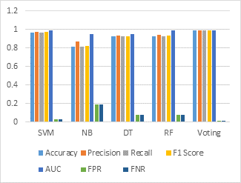

The comparison graph for NSL-KDD demonstrates that the Voting Classifier achieves the highest performance across all metrics (Accuracy: 98.6%, Precision: 98.7%, Recall: 98.7%, F1-Score: 98.6%, AUC: 0.989) with the lowest FPR and FNR of 0.014. SVM follows with 96.9% accuracy, while Naive Bayes shows the lowest performance at 81.0%, reflecting its limited capability on high-dimensional network traffic features.

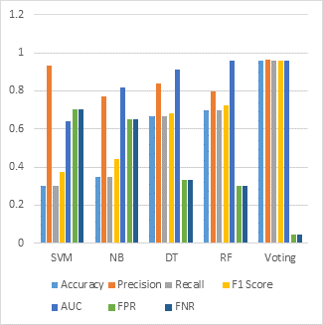

The comparison graph for CICIDS shows that the Voting Classifier again achieves the best results (95.7% accuracy, 96.6% precision, AUC: 0.956). The significantly lower accuracy of SVM (29.9%) on CICIDS2017 highlights the importance of ensemble methods for cross-dataset generalization with modern, complex attack traffic.

  - Tabular results

Table 1: Performance Evaluation – NSL-KDD Dataset

ML Model | Accuracy | Precision | Recall | F1  Score | AUC | FPR | FNR
SVM | 0.969 | 0.973 | 0.969 | 0.971 | 0.992 | 0.031 | 0.031
Naive Bayes | 0.810 | 0.869 | 0.810 | 0.824 | 0.953 | 0.190 | 0.190
Decision Tree | 0.926 | 0.933 | 0.926 | 0.928 | 0.952 | 0.074 | 0.074
Random Forest | 0.928 | 0.944 | 0.928 | 0.936 | 0.989 | 0.072 | 0.072
Voting Classifier | 0.986 | 0.987 | 0.986 | 0.987 | 0.989 | 0.014 | 0.014

Table 1 presents performance on NSL-KDD. The Voting Classifier achieves the highest accuracy of 98.6% with the lowest FPR/FNR of 0.014, demonstrating superior detection performance compared to all individual classifiers.

Table 2: Performance Evaluation – CICIDS2017 Dataset

ML Model | Accuracy | Precision | Recall | F1 Score | AUC | FPR | FNR
SVM | 0.299 | 0.930 | 0.299 | 0.373 | 0.639 | 0.701 | 0.701
Naive Bayes | 0.348 | 0.772 | 0.348 | 0.442 | 0.817 | 0.652 | 0.652
Decision Tree | 0.668 | 0.838 | 0.668 | 0.683 | 0.912 | 0.332 | 0.332
Random Forest | 0.697 | 0.799 | 0.697 | 0.726 | 0.956 | 0.303 | 0.303
Voting Classifier | 0.957 | 0.966 | 0.957 | 0.959 | 0.956 | 0.043 | 0.043
Table 2 presents performance on CICIDS2017. The Voting Classifier achieves 95.7% accuracy with 96.6% precision, maintaining the lowest FPR/FNR (0.043) and demonstrating robust generalization to this challenging, modern attack dataset.

  - Screenshot of Implementation


Step 1: Copy the code folder path.
Step 2
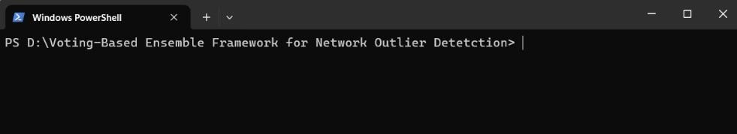
Step 2: Open path in Terminal

Step 3
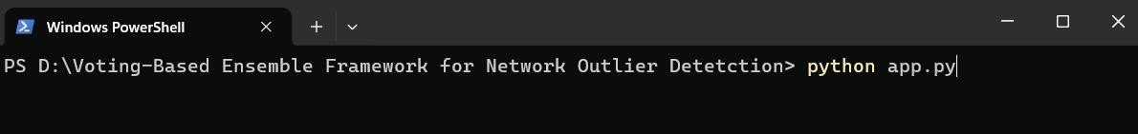
Step 3: Run the app with the command python <space> <main folder>.py

Step 4
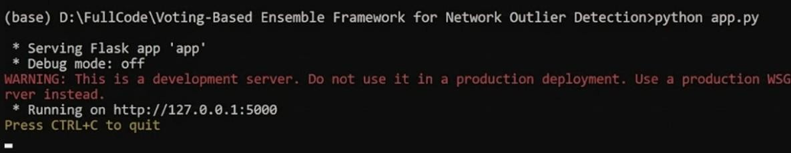
Step 4: Copy the web address

Step 5

Step 5: Open the web address in Chrome Browser

Dashboard - User Interface


Now you can see the Welcome Dashboard.
New users should click register with their credentials before trying to login.

Step 7

Step 6



Step 6: Register with your credentials.
Step 7: Login with username and password you’ve registered just now.

Step 8

After login select any one dataset and give the input values in the input fields. Now repeat the process with the other dataset.

Step 9 Test case 1
Step 9 Test case 2
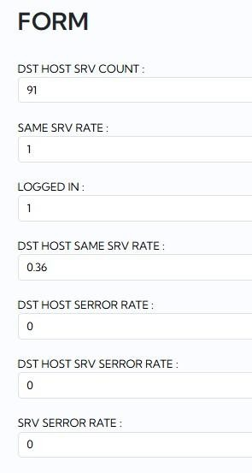
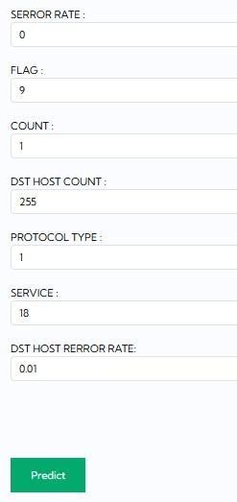
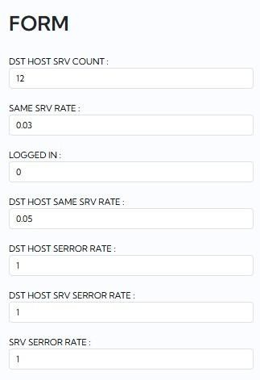
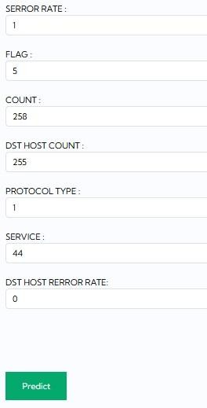



Step 9: Test case 1 & 2
After giving all the required input values, click on predict to view whether it is normal or any attack is occurred. If any attack is occurred it will show the type of attack.

Step 9 Test case 3
Step 9 Test case 4
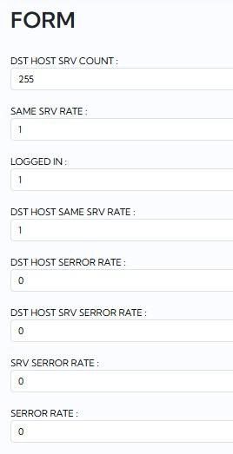
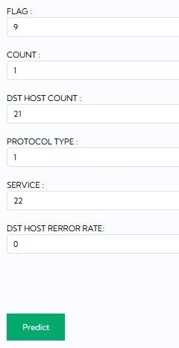
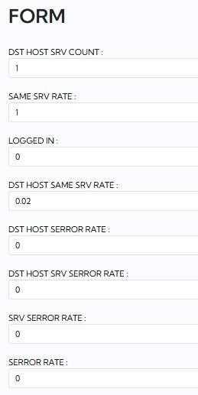
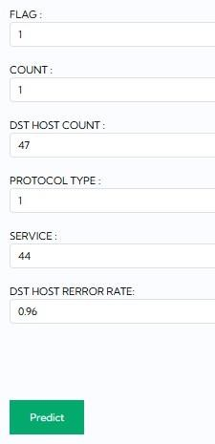



Step 9: Test case 3 & 4
Repeat the above process with different input values to test multiple times and predict the tests using multiple ML models.

Step 10 Test case 3 Step 10 Test case 4
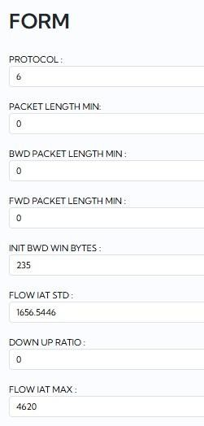
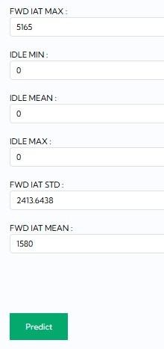
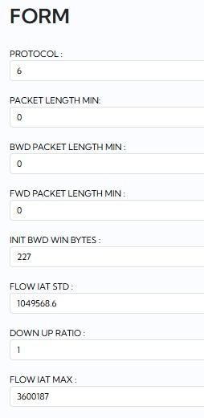
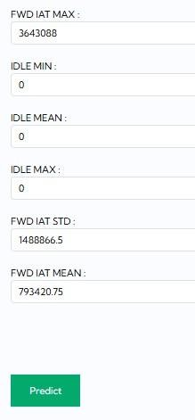



Step 10: Test Case 3 & 4
From the above figures as you can see there are two different types of attacks detected.

Step 11 Test case 5
Step 11 Test case 6
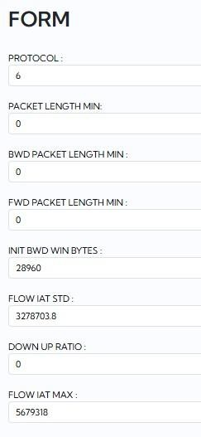
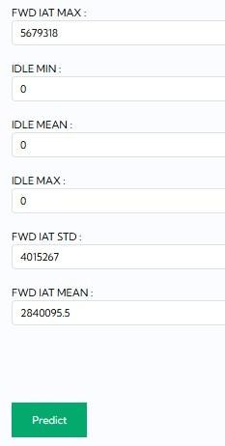
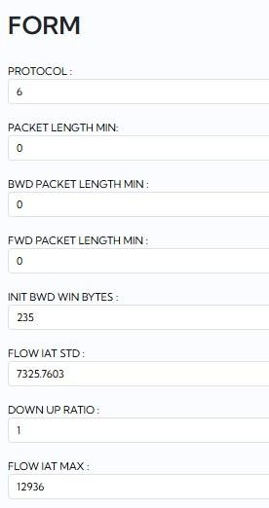
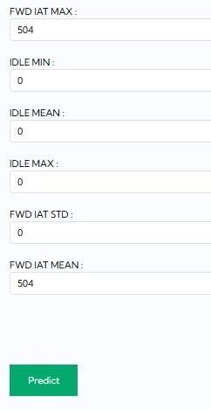



Step 11: Test Case 5 & 6
From the above figures as you can see there are two different types of attacks detected.

- CONCLUSION AND FUTURE DIRECTIONS

  - Conclusion
Thesis work introduced an efficient Ensemble-based NODS for anomaly-based intrusion detection based on the NSL-KDD and CICIDS2017 dataset benchmarking. The introduced NODS uses a systematic preprocessing pipeline in conjunction with the ensemble-based voting classifier made up of Bagging classifier, Ada Boost classifier, and decision tree classifier.
The voting classifier model outperforms the rest with the highest performance measures, including an accuracy of 98.6%, precision and recall of 98.7%, and AUC of 0.989 on NSL-KDD dataset, while on CICIDS2017, the voting classifier achieved an accuracy of 95.7% and precision of 96.6%. The front end with authentication developed using Flask makes the NODS practical.

  - Future Direction

Adaptive Online Learning:

Currently, the system uses a fixed-trained model, but future development of the proposed framework can include methods for online learning, where the model learns continuously by updating itself based on incoming information. In this way, it will be able to adapt to new attack trends and mitigate zero-day attacks, as well as decrease performance deterioration over time. Feedback mechanisms for improving accuracy of prediction could also be introduced through feedback loops.

IoT and Edge Devices Utilization:

By designing an efficient implementation, it is possible to deploy the proposed framework on low-resource devices such as IoT sensors and edge computing units. In this way, it will become more applicable to fast and real-time threat detection, especially for smart environments and 5G communication channels. Also, techniques of model compression can be used to save on computation and memory resources.

Distributed Computing Integration:

To analyse huge amounts of traffic coming from different channels at once, it is necessary to integrate the proposed method into frameworks such as Apache Spark and Kafka, which allow for the parallel processing of data. By integrating the proposed method with distributed computing, we will be able to perform real-time stream data analytics.

Audit Trails Using Blockchain Technology:

It is possible to use blockchain technology to record detection logs securely and in a tamper-proof way. This will guarantee data integrity and aid in forensic investigation, auditing, and cybersecurity regulation compliance. Also, smart contracts may be created to automate alert validation and logging processes.

Incorporation of Real-Time Threat Intelligence Feeds:

Another way of improving the system is through the inclusion of real-time threat intelligence feeds from external cybersecurity sources. The inclusion of such feeds will assist in keeping the system up-to-date concerning new attacks. Constant updates from these sources will greatly aid in detecting unknown attacks.

Cloud-Based System Implementation:

It is possible for the intrusion detection system to be created and operated using cloud computing. This means that the system will not have to run on locally available computers.

Integration of Explainable AI (XAI):

In future iterations of this system, XAI methods like SHAP and LIME can be implemented. They are useful in understanding how the AI makes its decision. Such knowledge will be helpful for network administrators and will improve the trustworthiness of the system. Proper explanations will also be handy for debugging purposes and will lead to better model performance.

Hybrid Deep Learning Techniques:

More sophisticated deep learning models like Convolutional Neural Networks (CNN), Recurrent Neural Networks (RNN) and Long Short-Term Memory (LSTM) can be integrated in this project. Their combination with other machine learning algorithms will provide even better results regarding classification.

Class Imbalance Handling Methods:

SMOTE can be applied to handle class imbalance problems in datasets. It will significantly contribute to detecting the attacks that do not occur very often but may still be crucial. Moreover, other sampling and weight adjustment methods can be introduced.

Automated Feature Engineering:

A future step could involve using AI algorithms for automated feature engineering. This would save time and effort and result in higher-performing models. Furthermore, it would assist in uncovering any underlying pattern which is otherwise difficult to discern using manual methods.

Integrations with Other Security Systems:

The system could be made to integrate with firewalls, IPS, and SIEM tools. This would allow the creation of automatic response mechanisms like blocking of malicious traffic.

Improved User Interface:

The web-based interface of the application could be upgraded with advanced features such as dashboards, real-time graphs, and alert notifications.

REFERENCES

- L. Almuqren, M. S. Maashi, M. Alamgeer, H. Mohsen, M. A. Hamza, and A. A. Abdelmageed, "Explainable artificial intelligence enabled intrusion detection technique for secure cyber-physical systems," Appl. Sci., vol. 13, no. 5, Art. no. 3081, Feb. 2023.
- Y. N. Rao and K. S. Babu, "An imbalanced generative adversarial network-based approach for network intrusion detection in an imbalanced dataset," Sensors, vol. 23, no. 1, Art. no. 550, Jan. 2023.
- O. Elnakib, E. Shaaban, M. Mahmoud, and K. Emara, "EIDM: Deep learning model for IoT intrusion detection systems," J. Supercomput., vol. 79, no. 12, pp. 13241-13261, Aug. 2023.
- S. S. Sathiyadhas and M. C. V. Soosai Antony, "A network intrusion detection system in cloud computing environment using dragonfly improved invasive weed optimization integrated Shepard convolutional neural network," Int. J. Adapt. Control Signal Process., vol. 36, no. 5, pp. 1060-1076, May 2022.
- S. Patil et al., "Explainable artificial intelligence for intrusion detection system," Electronics, vol. 11, no. 19, Art. no. 3079, 2022.
- J. Zhang and M. Zulkernine, "Anomaly-based network intrusion detection with unsupervised outlier detection," in Proc. IEEE Int. Conf. Commun. (ICC), Istanbul, Turkey, Jun. 2006, pp. 2388-2393.
- P. Gogoi, D. K. Bhattacharyya, B. Borah, and J. K. Kalita, "A survey of outlier detection methods in network anomaly identification," Comput. J., vol. 54, no. 4, pp. 570-588, Apr. 2011.
- S. Suthaharan, "Support vector machine," in Machine Learning Models and Algorithms for Big Data Classification, vol. 36, Berlin, Germany: Springer, 2016, pp. 207-235.
- L. Dhanabal and S. P. Shantharajah, "A study on NSL-KDD dataset for intrusion detection system based on classification algorithms," Int. J. Adv. Res. Comput. Commun. Eng., vol. 4, no. 6, pp. 446-452, Jun. 2015.
- I. Sharafaldin, A. H. Lashkari, and A. A. Ghorbani, "Toward generating a new intrusion detection dataset and intrusion traffic characterization," in Proc. 4th Int. Conf. Inf. Syst. Secur. Privacy (ICISSP), Funchal, Portugal, Jan. 2018, pp. 108-116.

- M. Tavallaee, E. Bagheri, W. Lu, and A. A. Ghorbani, "A detailed analysis of the KDD CUP 99 dataset," in Proc. IEEE Symp. Comput. Intell. Security Defense Appl. (CISDA), Ottawa, ON, Canada, Jul. 2009, pp. 1-6.
- A. Aburomman and M. B. I. Reaz, "A novel SVM-kNN-PSO ensemble method for intrusion detection system," Appl. Soft Comput., vol. 38, pp. 360-372, Jan. 2016.
- W. Li, P. Yi, Y. Wu, L. Pan, and J. Li, "A new intrusion detection system based on KNN classification algorithm in wireless sensor network," J. Electr. Comput. Eng., vol. 2014, Art. no. 240217, 2014.
- A. Khraisat, I. Gondal, P. Vamplew, and J. Kamruzzaman, "Survey of intrusion detection systems: Techniques, datasets and challenges," Cybersecurity, vol. 2, no. 1, Art. no. 20, Dec. 2019.

22091A3754 SONGA VENUGOPAL
Voting Based Ensemble Framework for NOD
 Project
 RGMCSECS  RGMCET-EB

Document Details

Submission ID trn:oid:::1:3553374887

51 Pages

7,695 Words

44,965 Characters
Submission Date
Apr 28, 2026, 2:43 PM GMT+5:30

Download Date
Apr 28, 2026, 2:45 PM GMT+5:30

File Name Voting_Based_Ensemble_Framework_for_NOD_4.pdf
File Size
1.8 MB

19% Overall Similarity
The combined total of all matches, including overlapping sources, for each database.

Match Groups
 101 Not Cited or Quoted 19%
Matches with neither in-text citation nor quotation marks
 0 Missing Quotations 0%
Matches that are still very similar to source material
 0 Missing Citation 0%
Matches that have quotation marks, but no in-text citation
 0 Cited and Quoted 0%
Matches with in-text citation present, but no quotation marks
Top Sources

9% |   Internet sources
9% |   Publications
9% |  Submitted works (Student Papers)

Integrity Flags
0 Integrity Flags for Review

Our system's algorithms look deeply at a document for any inconsistencies that would set it apart from a normal submission. If we notice something strange, we flag it for you to review.

A Flag is not necessarily an indicator of a problem. However, we'd recommend you focus your attention there for further review.
No suspicious text manipulations found.

Match Groups
101 Not Cited or Quoted 19%
Matches with neither in-text citation nor quotation marks
0 Missing Quotations 0%
Matches that are still very similar to source material
0 Missing Citation 0%
Matches that have quotation marks, but no in-text citation
0 Cited and Quoted 0%
Matches with in-text citation present, but no quotation marks
Top Sources

9% | Internet sources
9% | Publications
9% | Submitted works (Student Papers)

Top Sources
The sources with the highest number of matches within the submission. Overlapping sources will not be displayed.
1
Student papers
Jawaharlal Nehru Technological University Anantapur 5%
2
Internet

www.mdpi.com <1%
3
Internet

researchonline.gcu.ac.uk <1%
4
Publication

Jaskaran Singh, Meenu Gupta, Rakesh Kumar. "Smart Technologies and Intelligen… <1%
5
Internet

www.geeksforgeeks.org <1%
6
Internet

eudoxuspress.com <1%
7
Internet

link.springer.com <1%
8
Student papers

Asia Pacific Instutute of Information Technology <1%
9
Publication

Anshuman Tripathi, Shilpi Birla, Mamta Soni, Jagrati Sahariya, Monica Sharma. "… <1%
10
Internet

doctorpenguin.com <1%

11
Publication
Arvind Dagur, Sohit Agarwal, Dhirendra Kumar Shukla, Shabir Ali, Sandhya Sharm… <1%
12
Student papers

Colorado Technical University Online <1%
13
Student papers

University of Westminster <1%
14
Student papers

GMR Institute of Technology <1%
15
Student papers

Richfield Graduate Institute of Technology <1%
16
Internet

www.biotech-asia.org <1%
17
Internet

www.compbiosci.com <1%
18
Student papers

University of Teesside <1%
19
Internet

dirros.openscience.si <1%
20
Student papers

George Mason University <1%
21
Student papers

Taylor’s Education Group <1%
22
Student papers

University of Wales Institute, Cardiff <1%
23
Publication

Anurag Tiwari, Manuj Darbari. "Emerging Trends in Computer Science and Its Ap… <1%
24
Publication

Shankar Babu, Mahesh Babu Kota. "Synergies in Smart and Virtual Systems using… <1%

25
Publication
Sukhpreet Kaur, Amanpreet Kaur, Manish Kumar. "Recent Advances in Computati… <1%
26
Internet

dergipark.org.tr <1%
27
Internet

www.ssgmce.ac.in <1%
28
Publication

Anjan Bandyopadhyay, Tanvir Habib Sardar, Saurav Mallik, Ruhul Amin Hazarika, … <1%
29
Publication

Bhargav Appasani, Amitkumar Vidyakant Jha. "Engineering Applications of AI for … <1%
30
Student papers

Faculty of Engineering, Chulalongkorn University <1%
31
Internet

catalog.liha-pres.eu <1%
32
Internet

medinform.jmir.org <1%
33
Publication

H.L. Gururaj, Francesco Flammini, S. Srividhya, M.L. Chayadevi, Sheba Selvam. "Co… <1%
34
Publication

Sumika Chauhan. "Diversity-Driven Evolutionary Algorithms For Solving Engineer… <1%
35
Student papers

University of Central Lancashire <1%
36
Student papers

University of Northumbria at Newcastle <1%
37
Internet

kylo.tv <1%
38
Internet

warse.org <1%

39
Internet
cuestionesdefisioterapia.com <1%
40
Internet

jurnal.atmaluhur.ac.id <1%
41
Internet

www.thedesignengineering.com <1%
42
Publication

Li Fei, Zhang Jiayan, Edward Szczerbicki, Song Jiaqi, Li Ruxiang, Diao Renhong. "D… <1%
43
Internet

irjaeh.com <1%
44
Internet

nexusgames.to <1%
45
Internet

oceandatamining.sciencesconf.org <1%
46
Internet

archive.org <1%
47
Internet

text.uscannenbergmedia.com <1%
48
Internet

www.atlantis-press.com <1%
49
Internet

www.wanghao.in <1%
50
Student papers

Arab Open University <1%
51
Internet

accentsjournals.org <1%
52
Internet

dspace.daffodilvarsity.edu.bd:8080 <1%

53
Internet
ijsrcseit.com <1%
54
Internet

publications.imp.fu-berlin.de <1%
55
Internet

discuss.cloudxlab.com <1%
56
Internet

rockenzo.github.io <1%
57
Internet

univ-eltarf.dz <1%
58
Internet

www.thesciencepostjournal.com <1%
59
Publication

Pushpa Choudhary, Sambit Satpathy, Arvind Dagur, Dhirendra Kumar Shukla. "Re… <1%
60
Publication

Al Banna, Saeed. "Integration of Blockchain and Machine Learning for Robust Int… <1%
61
Publication

Dhirendra Kumar Shukla, Shabir Ali, Sandhya Sharma. "Artificial Intelligence and … <1%
62
Publication

Fereshteh Abbasi, Marjan Naderan, Seyed Enayatallah Alavi. "Dimensionality red… <1%
63
Publication

Harvinder Singh, Priyanka Kaushal, Sarabjeet Kaur. "Advanced Computing and AI… <1%









Voting-Based Ensemble Framework for Network Outlier Detection

Muneiah Tellakula Assistant professor Department of CSE(CS)
Rajeev Gandhi Memorial College of Engineering and Technology Nandyal -518501,
Andhra Pradesh,
Email: muneiahtellakula@gmail.com
Kateef Nabi Rasul Department of CSE(CS)
Rajeev Gandhi Memorial College of Engineering and Technology Nandyal -518501,
Andhra Pradesh,
Email: khathifnabirasool@gmail.com

Songa Venu Gopal Department of CSE(CS)
Rajeev Gandhi Memorial College of Engineering and Technology Nandyal -518501,
Andhra Pradesh,
Email: songavenugopal@gmail.com
Mallepogu Kalyan Department of CSE(CS)
Rajeev Gandhi Memorial College of Engineering and Technology Nandyal -518501,
Andhra Pradesh,
Email: kurnoolkalyan82@gmail.com

Abstract— With the rapid escalation of cyber-attacks and sophisticated intrusion techniques, robust anomaly-based detection mechanisms have become critical for safeguarding modern network infrastructures. This paper proposes an optimized Network Outlier Detection System (NODS) designed to identify and classify malicious network traffic with high reliability. The system is evaluated using the NSL-KDD and CICIDS2017 benchmark intrusion detection datasets. Comprehensive preprocessing, including Min–Max and Z-score normalization, is applied, followed by dimensionality reduction and feature optimization using Principal Component Analysis (PCA) and Correlated Feature Selection (CFS). Multiple machine learning classifiers—Support Vector Machine (SVM), Naïve Bayes, Decision Tree, Random Forest, and an ensemble Voting Classifier—are implemented for comparative performance analysis. Experimental results demonstrate that the ensemble Voting Classifier achieves superior performance, attaining an accuracy of 98.6%, precision of 98.7%, recall of 98.7%, F1-score of 98.6%, and an AUC of 0.989, thereby outperforming individual models. The proposed framework offers enhanced robustness and reliability for real-time network intrusion detection and proactive cyber-defense systems.
Keywords— Anomaly detection, Intrusion detection systems (IDS), Network security, Ensemble learning, Feature selection, Machine learning.
- Introduction
Internet technology and communication infrastructures continue to expand at an unprecedented scale, significantly increasing the attack surface of modern cyber-physical and cloud-enabled systems. Consequently, sophisticated cyber-attacks and zero-day exploits have intensified, demanding advanced intrusion detection mechanisms capable of ensuring confidentiality, integrity, and availability of networked systems [1], [2]. Network intrusions are characterized by abnormal or malicious traffic behaviors that deviate from legitimate communication patterns. Outlier detection techniques are widely adopted to identify such anomalous activities by distinguishing statistically rare or behaviorally inconsistent data instances from normal network traffic [6], [7].
A Network Outlier Detection System (NODS) provides a systematic framework for monitoring host-level activities or network-level traffic flows to detect potential security breaches. Unlike signature-based methods, which rely on predefined attack patterns and fail against unknown threats, anomaly-based approaches model normal behavior and detect deviations, thereby enabling zero-day attack detection [3]. Recent advancements integrate machine learning, deep learning, and optimization strategies to enhance detection accuracy and robustness in complex environments such as cloud and IoT networks [4]. Furthermore, explainable artificial intelligence (XAI) techniques are increasingly incorporated to improve transparency and trustworthiness in intrusion detection decisions [1], [5].
- Related Work
Machine learning techniques have significantly advanced intrusion detection systems (IDS) by enabling automated classification of anomalous network behaviors. Support Vector Machine (SVM) remains one of the most widely adopted classifiers due to its strong structural risk minimization principle and robustness in high-dimensional spaces [8]. Hybrid approaches, such as SVM–kNN–PSO ensembles, have further improved detection performance through optimization-driven model tuning and classifier fusion [12]. Likewise, K-Nearest Neighbor (KNN) has demonstrated effectiveness in specific deployment scenarios such as wireless sensor networks [13].
Benchmark datasets play a crucial role in IDS validation. The NSL-KDD dataset mitigates redundancy issues found in KDD Cup 99 and provides a balanced evaluation environment [9], [11], whereas CICIDS2017 introduces modern attack vectors and realistic traffic distributions suitable for evaluating contemporary detection systems [10]. Despite their widespread use, many studies report performance improvements on a single dataset, limiting cross-dataset generalization analysis.
Recent surveys emphasize persistent challenges including class imbalance, feature redundancy, evolving attack strategies, and limited model interpretability [14], [16].

Although explainable artificial intelligence (XAI) techniques have been introduced to enhance transparency in anomaly detection models [15], the majority of existing works focus either on single optimized classifiers or on hybrid models without systematic preprocessing pipelines.
Existing IDS frameworks often lack an integrated architecture that combines (i) robust normalization strategies,
(ii) dimensionality reduction and correlation-based feature optimization, and (iii) a statistically grounded ensemble voting mechanism that aggregates heterogeneous classifiers to improve stability and generalization across multiple benchmark datasets. Furthermore, limited studies provide a comprehensive comparative evaluation of ensemble voting architectures on both NSL-KDD and CICIDS2017 under identical preprocessing conditions.
Therefore, there is a clear need for a unified anomaly-based Network Outlier Detection System that systematically integrates Min–Max and Z-score normalization, PCA and CFS feature selection, and a hybrid Voting Classifier combining bagged Random Forest and boosted Decision Tree models to achieve enhanced detection accuracy, robustness, and reduced false alarm rates across diverse intrusion datasets.
- Materials And Methods
- Problem Formulation
Let the network traffic dataset be represented as:
𝐷 = {(𝑥𝑖, 𝑦𝑖)}^{𝑁} (1)
𝑖=1
where:

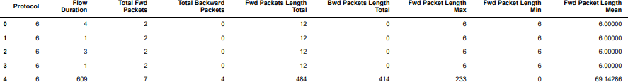

Fig.1 Dataset
Figure 1 presents a sample representation of the dataset structure used in this study, illustrating key network flow features extracted from traffic records. The table includes attributes such as protocol type, flow duration, forward and backward packet counts, total packet lengths, and statistical measures including minimum, maximum, and mean packet lengths. These flow-based characteristics capture both directional traffic behavior and temporal properties, providing discriminative information necessary for anomaly detection and accurate classification of normal and malicious network activities.
- Data Preprocessing
  - Label Encoding
Categorical attributes such as protocol type and service are converted into numerical representations using label encoding:
𝑥𝑐𝑎𝑡 → {0, 1, 2, … , 𝜅} (3)
  - Feature Scaling
To ensure uniform contribution of features, Min-Max normalization is applied:

    - 𝑥𝑖 ∈ ℝ^{𝑑} denotes the feature vector of the 𝑖^{𝑡ℎ}
network connection
𝑥′ = 𝑥 − 𝑥𝑚𝑖𝑛
𝑥𝑚𝑎𝑥 − 𝑥𝑚𝑖𝑛
(4)

    - 𝑦𝑖 ∈ {0,1} represents the class label
      - 0 → Normal traffic
      - 1 → Anomalous traffic
The objective of the proposed Network Outlier Detection System (NODS) is to learn a classifier:
𝑓: ℝ^{𝑑} → {0, 1} (2)
that minimizes classification error while maximizing detection performance under highly imbalanced and high-dimensional intrusion data.
- Dataset Description
The proposed system is evaluated using two benchmark intrusion detection datasets:
  - NSL-KDD
  - CICIDS2017
NSL-KDD addresses redundancy issues present in KDD’99 and contains labeled network connection records with 41 features.
CICIDS2017 includes modern attack traffic such as DDoS, Brute Force, Botnet, and Infiltration attacks, making it suitable for evaluating real-world robustness.
No missing values were observed in the datasets.
This prevents dominance of high-magnitude attributes in distance-based models such as SVM.
  - Feature Selection
Dimensionality reduction is performed using: Principal Component Analysis (PCA) Correlation-based Feature Selection (CFS)
PCA transforms features into orthogonal principal components maximizing variance:
𝑍 = 𝑋𝑊 (5)
where 𝑊 represents eigenvectors of the covariance matrix.
CFS removes redundant features by evaluating feature-class and feature-feature correlations.
- Proposed Voting-Based Ensemble Framework
The proposed model integrates multiple heterogeneous classifiers to improve detection robustness.
  - Base Classifiers
The following classifiers are trained independently:
    - Support Vector Machine (RBF Kernel)
    - Naïve Bayes
    - Decision Tree

    - Random Forest
Each classifier produces a prediction:
ℎ𝑖(𝑥) ∈ {0, 1} (6)
  - Ensemble Construction
Unlike traditional single-model IDS approaches, the proposed framework introduces a weighted voting mechanism combining:
    - Bagged Random Forest
    - Boosted Decision Tree
The final prediction is obtained using weighted majority voting:
𝑁
𝑦̂ = 𝑎𝑟𝑔 max ∑ 𝑤𝑖 1(ℎ𝑖(𝑥) = 𝑐) (7)
𝑐∈{0,1} 𝑖=1
where:
    - 𝑤𝑖 = weight assigned to classifier
    - 1(⋅) = indicator function
Weights are determined based on validation accuracy of individual classifiers.
This approach improves:
To ensure robustness:
    - 5-fold cross-validation is applied
    - Stratified sampling preserves class distribution
    - Hyperparameters are optimized using grid search
- Performance Evaluation Metrics
Model performance is evaluated using:
  - Accuracy
  - Precision
  - Recall
  - F1-score
Additionally, confusion matrix and ROC-AUC analysis are performed to assess anomaly detection capability under class imbalance.
- Experimental Results
Accuracy: The accuracy of a test is its ability to differentiate the patient and healthy cases correctly. To estimate the accuracy of a test, we should calculate the proportion of true positive and true negative in all evaluated cases. Mathematically, this can be stated as:
TP + TN

  - Generalization capability
𝐴𝑐𝑐𝑢𝑟𝑎𝑐𝑦 =

TP + FP + TN + FN
(8)

  - Robustness against noisy samples
  - Detection rate for minority attack classes
Precision: Precision evaluates the fraction of correctly classified instances or samples among the ones classified as positives. Thus, the formula to calculate the precision is given by:

𝑃𝑟𝑒𝑐𝑖𝑠𝑖𝑜𝑛 =
True Positive

True Positive + False Positive

(9)

Recall: Recall is a metric in machine learning that measures the ability of a model to identify all relevant instances of a particular class. It is the ratio of correctly predicted positive observations to the total actual positives, providing insights into a model's completeness in capturing instances of a given class.

𝑅𝑒𝑐𝑎𝑙𝑙 =
TP

TP + FN

(10)

Fig.2 System Architecture
Figure 2 illustrates the overall architecture of the proposed Network Outlier Detection System (NODS). The workflow begins with the NSL-KDD and CICIDS2017 datasets,
F1-Score: F1 score is a machine learning evaluation metric that measures a model's accuracy. It combines the precision and recall scores of a model. The accuracy metric computes how many times a model made a correct prediction across the entire dataset.
𝑅𝑒𝑐𝑎𝑙𝑙 X 𝑃𝑟𝑒𝑐𝑖𝑠𝑖𝑜𝑛

followed by data processing, visualization, and label encoding. Feature selection is performed prior to model
𝐹1 𝑆𝑐𝑜𝑟𝑒 = 2 ∗

𝑅𝑒𝑐𝑎𝑙𝑙 + 𝑃𝑟𝑒𝑐𝑖𝑠𝑖𝑜𝑛
∗ 100 (11)

training to enhance data relevance and reduce dimensionality. The framework integrates multiple classifiers, including SVM, Naïve Bayes, Decision Tree, Random Forest, and a Voting Classifier combining bagged Random Forest with boosted Decision Tree. The trained models are validated and evaluated using standard performance metrics.
AUC-ROC Curve: The AUC-ROC Curve is a performance measurement for classification problems at various threshold settings. ROC plots the True Positive Rate against the False Positive Rate. AUC quantifies the overall ability of the model to distinguish between classes, where a higher AUC indicates better model performance.

- Training and Validation Strategy
𝑛−1
𝐴𝑈𝐶 = ∑(𝐹𝑃𝑅

− 𝐹𝑃𝑅 ) ∙
𝑇𝑃𝑅𝑖+1
+ 𝑇𝑃𝑅𝑖

(12)

The dataset is partitioned using an 80:20 train-test split.

𝑖=1

𝑖+1 𝑖 2

Table.1 Performance Evaluation – NSL KDD

ML  Mod el | Accur acy | Precis ion | Rec all | F1  Sco re | AU C | FP R | FN R
SV M | 0.969 | 0.973 | 0.96  9 | 0.9  71 | 0.9  92 | 0.0  31 | 0.0  31
NB | 0.810 | 0.869 | 0.81  0 | 0.8  24 | 0.9  53 | 0.1  90 | 0.1  90
DT | 0.926 | 0.933 | 0.92  6 | 0.9  28 | 0.9  52 | 0.0  74 | 0.0  74
RF | 0.928 | 0.944 | 0.92  8 | 0.9  36 | 0.9  89 | 0.0  72 | 0.0  72
Voti ng | 0.986 | 0.987 | 0.98  6 | 0.9  87 | 0.9  89 | 0.0  14 | 0.0  14
Table 1 presents a comparative analysis of model performance on key metrics. The Voting Classifier stands out with the highest overall efficiency, exhibiting excellent accuracy, precision, recall, and lowest error rates.
Table.2 Performance Evaluation – CICIDS
ML  Mod el | Accur acy | Precis ion | Rec all | F1  Sco re | AU C | FP R | FN R
SV M | 0.299 | 0.930 | 0.29  9 | 0.3  73 | 0.6  39 | 0.7  01 | 0.7  01
NB | 0.348 | 0.772 | 0.34  8 | 0.4  42 | 0.8  17 | 0.6  52 | 0.6  52
DT | 0.668 | 0.838 | 0.66  8 | 0.6  83 | 0.9  12 | 0.3  32 | 0.3  32
RF | 0.697 | 0.799 | 0.69  7 | 0.7  26 | 0.9  56 | 0.3  03 | 0.3  03
Voti ng | 0.957 | 0.966 | 0.95  7 | 0.9  59 | 0.9  56 | 0.0  43 | 0.0  43

Fig.3 Comparison Graph – NSL KDD
Figure 3 illustrates the comparative performance of evaluated classifiers across multiple metrics, highlighting the ensemble model’s consistent superiority in accuracy, precision, recall, and AUC while maintaining minimal false positive and false negative rates.
1.2

1

0.8

0.6

0.4

0.2

0
SVM
NB
DT
RF
Voting
Accuracy Precision Recall
F1 Score
AUC FPR FNR
Fig.4 Comparison Graph – CICIDS
Figure 4 presents the comparative evaluation on the CICIDS dataset, demonstrating that the ensemble-based Voting Classifier achieves the most stable and superior performance across accuracy, precision, recall, AUC, and error-rate metrics.

Table 2 illustrates performance across multiple evaluation criteria. The Voting Classifier achieves the top results, delivering superior accuracy, precision, and recall while maintaining minimal false positive and negative rates.

1.2
1
0.8
0.6
0.4
0.2
0
SVM
NB
DT
RF
Voting
Accuracy Precision Recall
F1 Score
AUC FPR FNR
- Conclusion
This study presented a performance-driven ensemble-based Network Outlier Detection System (NODS) for anomaly-based intrusion detection. By integrating Min–Max normalization, dimensionality reduction through Principal Component Analysis, and correlation-based feature optimization, the proposed framework enhances data representation for classification. The weighted Voting Classifier, combining bagged Random Forest and boosted Decision Tree models, achieved superior detection performance, attaining 98.6% accuracy, 98.7% precision and recall, and an AUC of 0.989 across benchmark datasets. These results demonstrate improved robustness, reduced false alarm rates, and strong generalization capability for modern network traffic environments.
Despite its strong performance, the framework relies on supervised learning and benchmark datasets, which may not fully capture real-time evolving attack dynamics. Future research will focus on incorporating adaptive online learning mechanisms, cost-sensitive ensemble optimization for highly imbalanced traffic, and real-time deployment evaluation in distributed network environments. Additionally, lightweight deep hybrid architectures may be investigated to improve scalability while maintaining detection stability in large-scale enterprise networks.

References
- L. Almuqren, M. S. Maashi, M. Alamgeer, H. Mohsen, M. A. Hamza, and A. A. Abdelmageed, “Explainable artificial intelligence enabled intrusion detection technique for secure cyber-physical systems,” Appl. Sci., vol. 13, no. 5, Art. no. 3081, Feb. 2023, doi: 10.3390/app13053081.
- Y. N. Rao and K. S. Babu, “An imbalanced generative adversarial network-based approach for network intrusion detection in an imbalanced dataset,” Sensors, vol. 23, no. 1, Art. no. 550, Jan. 2023, doi: 10.3390/s23010550.
- O. Elnakib, E. Shaaban, M. Mahmoud, and K. Emara, “EIDM: Deep learning model for IoT intrusion detection systems,” J. Supercomput., vol. 79, no. 12, pp. 13241–13261, Aug. 2023, doi: 10.1007/s11227-
023-05043-4.
- S. S. Sathiyadhas and M. C. V. Soosai Antony, “A network intrusion detection system in cloud computing environment using dragonfly improved invasive weed optimization integrated Shepard convolutional neural network,” Int. J. Adapt. Control Signal Process., vol. 36, no. 5, pp. 1060–1076, May 2022, doi: 10.1002/acs.3375.
- S. Patil et al., “Explainable artificial intelligence for intrusion detection system,” Electronics, vol. 11, no. 19, Art. no. 3079, 2022, doi: 10.3390/electronics11193079.
- J. Zhang and M. Zulkernine, “Anomaly-based network intrusion detection with unsupervised outlier detection,” in Proc. IEEE Int. Conf. Commun. (ICC), Istanbul, Turkey, Jun. 2006, pp. 2388–2393, doi: 10.1109/ICC.2006.255127.
- P. Gogoi, D. K. Bhattacharyya, B. Borah, and J. K. Kalita, “A survey of outlier detection methods in network anomaly identification,” Comput. J., vol. 54, no. 4, pp. 570–588, Apr. 2011, doi: 10.1093/comjnl/bxr026.
- S. Suthaharan, “Support vector machine,” in Machine Learning Models and Algorithms for Big Data Classification, vol. 36, Berlin, Germany: Springer, 2016, pp. 207–235, doi: 10.1007/978-1-4842-2137-0_9.
- L. Dhanabal and S. P. Shantharajah, “A study on NSL-KDD dataset for intrusion detection system based on classification algorithms,” Int. J. Adv. Res. Comput. Commun. Eng., vol. 4, no. 6, pp. 446–452, Jun. 2015.
- I. Sharafaldin, A. H. Lashkari, and A. A. Ghorbani, “Toward generating a new intrusion detection dataset and intrusion traffic characterization,” in Proc. 4th Int. Conf. Inf. Syst. Secur. Privacy (ICISSP), Funchal, Portugal, Jan. 2018, pp. 108–116, doi: 10.5220/0006639801080116.
- M. Tavallaee, E. Bagheri, W. Lu, and A. A. Ghorbani, “A detailed analysis of the KDD CUP 99 dataset,” in Proc. IEEE Symp. Comput. Intell. Security Defense Appl. (CISDA), Ottawa, ON, Canada, Jul. 2009, pp. 1–6, doi: 10.1109/CISDA.2009.5356528.
- A. Aburomman and M. B. I. Reaz, “A novel SVM-kNN-PSO ensemble method for intrusion detection system,” Appl. Soft Comput., vol. 38,
pp. 360–372, Jan. 2016, doi: 10.1016/j.asoc.2015.10.011.
- W. Li, P. Yi, Y. Wu, L. Pan, and J. Li, “A new intrusion detection system based on KNN classification algorithm in wireless sensor network,” J. Electr. Comput. Eng., vol. 2014, Art. no. 240217, 2014, doi: 10.1155/2014/240217.
- A. Khraisat, I. Gondal, P. Vamplew, and J. Kamruzzaman, “Survey of intrusion detection systems: Techniques, datasets and challenges,” Cybersecurity, vol. 2, no. 1, Art. no. 20, Dec. 2019, doi: 10.1186/s42400-019-0038-7.
- L. Wawrowski et al., “Detecting anomalies and attacks in network traffic monitoring with classification methods and XAI-based explainability,” Procedia Comput. Sci., vol. 192, pp. 2259–2268, 2021, doi: 10.1016/j.procs.2021.09.001.
- M. Safaei Pour, C. Nader, K. Friday, and E. Bou-Harb, “A comprehensive survey of recent Internet measurement techniques for cyber security,” Comput. Secur., vol. 128, Art. no. 103123, May 2023, doi: 10.1016/j.cose.2023.103123.

